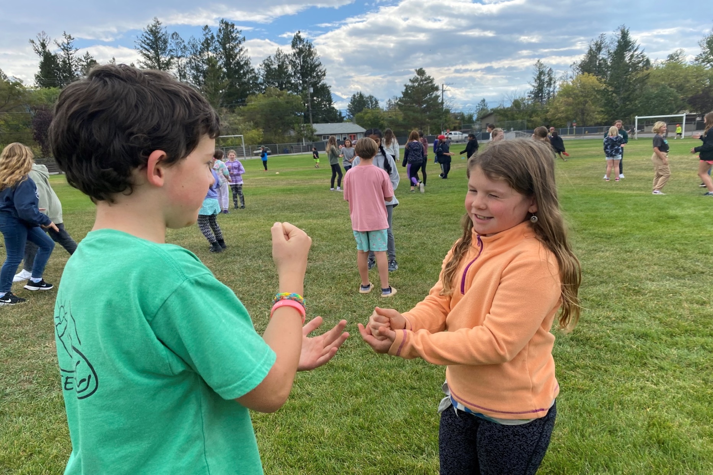

2024-2025

SCHOOL SUCCESS PLAN

J. A. Laird Elementary School

|  |  |
| --- | --- |
| Principal Message | |
| Indigenous peoples have populated this continent since time immemorial. In that time, they learned to not only survive, but thrive, working in harmony with the land. I believe we have much we can learn from Indigenous ways of knowing and being. Changing the relationship that many non-Indigenous people have with the land has the potential to lead to a healthier Earth for all.  Twelve of the Truth and Reconciliation Commission's Calls to Action are targeted toward educators. In addition, the Professional Standards for BC Educators require that, "educators respect and value the history of First Nations, Inuit and Métis in Canada and the impact of the past on the present and the future. Educators contribute toward truth, reconciliation and healing. Educators foster a deeper understanding of ways of knowing and being, histories and cultures of First Nations, Inuit and Métis."  Our School Success Plan for 2024-2025 seeks to move all of us: staff, students and our community, further along this path toward truth and reconciliation. As former Truth and Reconciliation Commission of Canada (TRC) Chair, The Honourable Murray Sinclair stated, “Education is what got us into this mess and education is key to getting us out of it"  This plan was developed in conjunction with all school staff. A draft plan was presented to our Parent Advisory Committee in May 2024, and a survey soliciting feedback from our school community was sent to all families in June 2024. The most prevalent feedback expressed the hope that our plan would assist students to become better social problem-solvers. It is our hope that adopting Indigenous ways of knowing and being will, in fact, support students in self-regulation and restorative practice to resolve social challenges.  Terri Ann Hayes  Principal |  |

|  |  |
| --- | --- |
| school demographics | |
| Staff   * 1.4 Learning Services Teachers * 9 Classroom teachers * 1 Youth Care Worker * 1 Teacher-librarian * 8 Education Assistants * 1 IESW * 1Admin Assistant * 1 Principal, 1 Vice-principal | Students   * 240 students * 50 Indigenous students |
| Grades   * Grade 4 - 50 * Grade 5 - 59 * Grade 6 - 67 * Grade 7- 64 |  |

|  |  |  |
| --- | --- | --- |
| Vision | mission | |
| Our vision is to create a safe and dynamic learning environment that fosters personal growth, curiosity, confidence and compassion. | At J. Alfred Laird Elementary School, our mission is to nurture the intellectual, social, emotional, and physical growth of every student, in collaboration with our families and community. | |
| values | | |
| Community: We work together to make our school a safe, welcoming and joyful place for everyone.  Caring: We take care of ourselves, each other, our school, our family, our community, and the earth.  Diversity, Equity and Inclusion: We value, respect, and support every person in our school community.  Responsibility: We take ownership of our words, our actions, our work habits and our learning. | |  |

|  |  |
| --- | --- |
| thematic narrative We examined a range of school data, as well as anecdotal evidence, in order to arrive at our School Success Plan goals for 2024-2025. | |
| Our student learning survey results indicate that many of our students feel they never or almost never participate in Indigenous activities and celebrations. Some report that they never or almost never learn about Indigenous Peoples, and that they never or almost never learn about local First Nations (please see the chart below).    Anecdotally, several of our teachers are from other regions of Canada, and have expressed difficulty in infusing Indigenous knowledge and ways of knowing into the curriculum, because they have not yet been able to forge connections to our local communities, and to build their own understanding.  As a school community, we still have work to do to become more aware of and to wipe out racism. There continue to be incidents of micro-aggression and racism directed toward our Indigenous students.  Examining evidence from a range of formal and informal assessments and data analysis provides us with areas of focus this year. All students demonstrate better achievement when they feel valued and respected, and our goal is to ensure that all students, and our Indigenous students, in particular, feel seen and valued for their unique gifts, talents, learning styles and abilities.  We know that what is good pedagogy for Indigenous learners is good pedagogy for all learners. Learning from the land, engaging in hands-on learning, and considering diverse perspectives promotes positive physical and mental health, and supports Core Competencies such as critical and reflective thinking, creating citizens who are willing to question and challenge their own thoughts, ideas, and assumptions and challenge those of others. Goal **We seek to improve student outcomes across all domains (academic, social-emotional, spiritual and physical) by furthering our school's collective journey toward Truth and Reconciliation. We will embed the First Peoples' Principles of Learning in all that we do.** |  |

|  |  |
| --- | --- |
| equity, Diversity and Inclusion Learning is holistic, reflexive, reflective, experiential, and relational. | |
| Inquiry If school staff and students regularly engage with Indigenous community members, can we build upon our current relationships with our Indigenous community, leading to our Indigenous students demonstrating greater engagement in their learning, pride in their culture and language, and confidence in their abilities? | Action In conjunction with our Indigenous Education Support Worker, the Akisqnuk Education and Workforce Coordinator, and the Shuswap Navigator, the school will grow our Elder-in-Residence program to ensure that local Elders are visible, not just in the Indigenous Education Support Room, but throughout the school.  AND  School staff will build connection to our Indigenous families by hosting three events for our Indigenous families in the next school year (feast night, and two parent-teacher conference nights on-reserve) |
| Data and Monitoring We will survey our Indigenous students 3 times in the next school year: at the beginning of the year, in January and again in June to monitor their feelings of belonging, engagement in their learning, and perceptions of themselves as learners.  We will also monitor the number of Indigenous families who participate in our feast night and on-reserve parent-teacher conferences. | |

|  |  |
| --- | --- |
| success for each learner Learning is embedded in memory, history, and story. | |
| Inquiry Will a focus on oral storytelling and the use of story to teach across curriculum areas result in increased student performance in developing ideas, communicating ideas and information, and comprehending text? | Action Teachers will intentionally choose story and narrative to teach concepts across all curriculum areas: particularly in literacy and numeracy. |
| Data and Monitoring At least three times per year (November, February and May) we will use the BC Ministry of Education Literacy Pathways to collaboratively evaluate students’ oral, digital, and written work to measure progress toward the three aspects of developing ideas, communicating ideas and information, and comprehending text. We will track the progress of a select group of students to monitor whether this strategy has had a positive impact.  We will also collect report card data three times per year to monitor student progress. | |

|  |  |
| --- | --- |
| Growing Capacity of Self and Others Learning recognizes the role of Indigenous knowledge. | |
| Inquiry Will providing regular opportunities for the staff in our building to learn from Indigenous authors and knowledge holders lead to greater confidence in infusing Indigenous ways of knowing across the curriculum? | Action In the 2024-2025 school year, all school staff will participate in monthly collaborative learning, which may include book clubs focused on books by Indigenous authors, or the Four Seasons of Indigenous Learning: A Personal Journey Toward Truth and Reconciliation. |
| Data and Monitoring We will survey staff at the beginning and end of the school year to assess their confidence and experiences in infusing Indigenous ways of knowing throughout the curriculum.  At the end of each collaborative learning session, we will collect ideas and understandings that we can implement at the school in our effort to create a safe and supportive learning environment for our Indigenous students.  We will also track and document new initiatives we have implemented because of our shared learning. | |

|  |  |
| --- | --- |
| Stewardship for the Future Learning ultimately supports the well-being of the self, the family, the community, the land, the spirits, and the ancestors. | |
| Inquiry Will experiential, place-based learning opportunities increase students' sense of well-being, belonging, engagement and respect for the land? | Action Teachers and students will engage in monthly place-based learning opportunities that support them to learn from the land. Whenever possible, Indigenous Elders and knowledge holders will be part of these learning opportunities. |
| Data and Monitoring We will monitor the responses on the Student Learning Survey and Middle Years Development Instrument (MDI) with a focus on questions related to belonging, mental health, and engagement in learning.  We will use student journals and anecdotal evidence to monitor students’ developing understanding and appreciation for stewardship of the land.  We will maintain a shared photo journal of the place-based learning activities taking place in the school. | |